Case 3-Asia-Indus-Jars-Tiger

8 cm height  
7.5 cm diameter  
Ex: European collection.

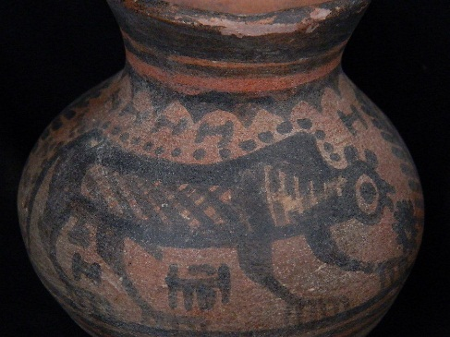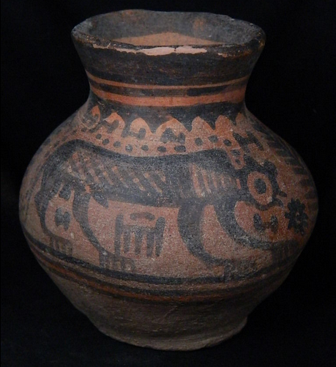 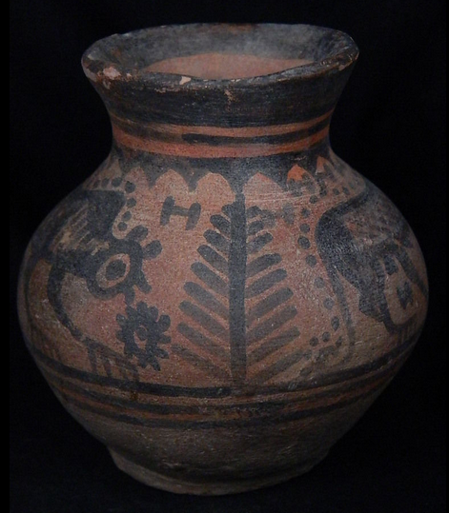

**Terracotta Painted Pot With Animals Indus Valley 2500 BCE**

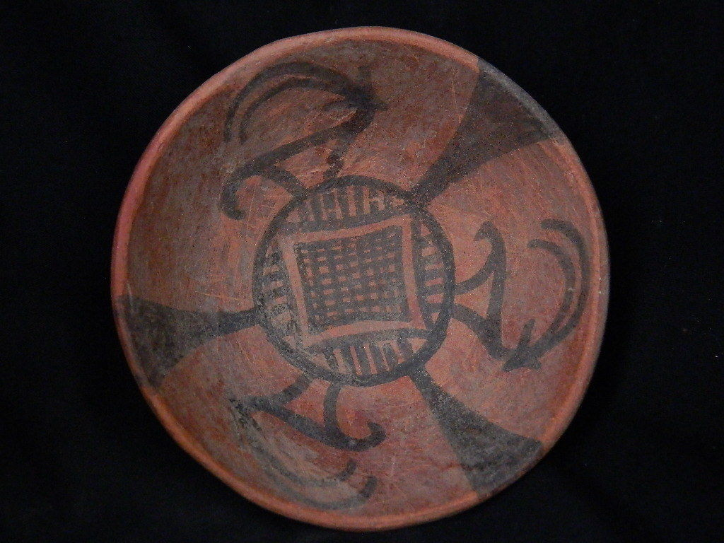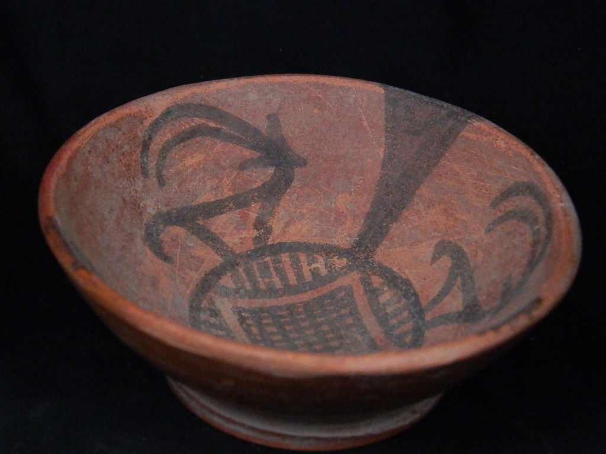

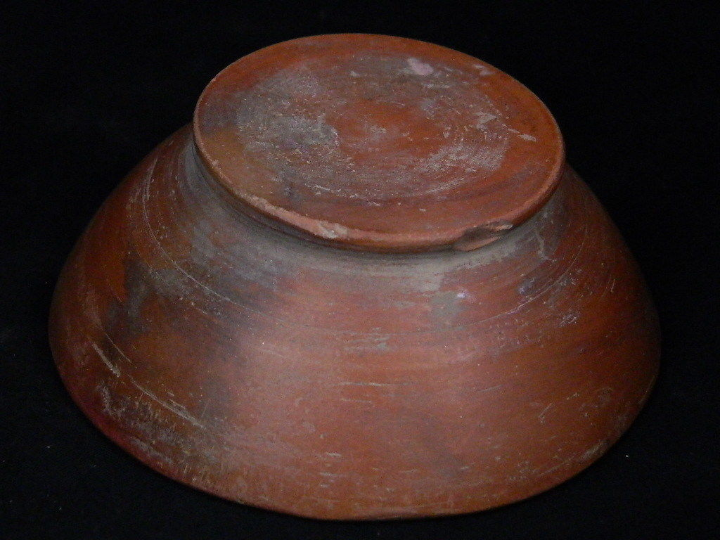

Ancient large size teracotta painted bowl with serpent indus valley circa 2500-3000 BC.  
Combine shipment for mulitiple purchases.  
Shipping/handling $20 worldwide.  
Repaired/Restored  
3 cm height  
14.5 cm diameter  
Ex: European collection

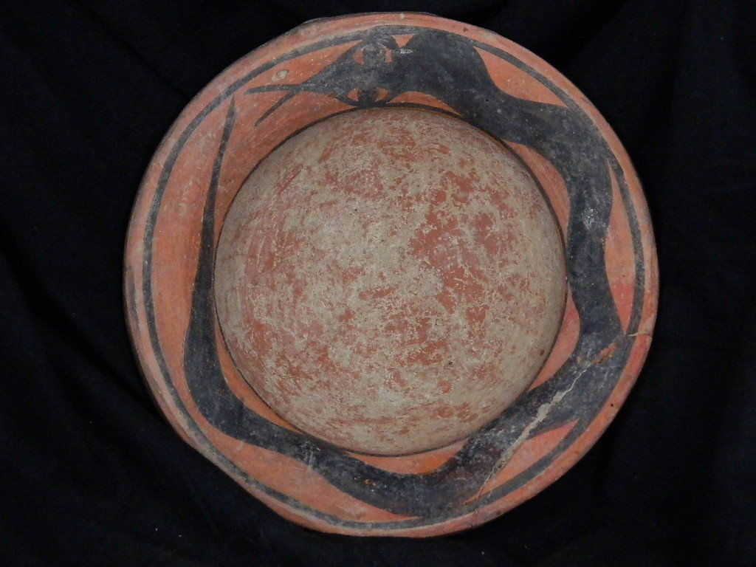

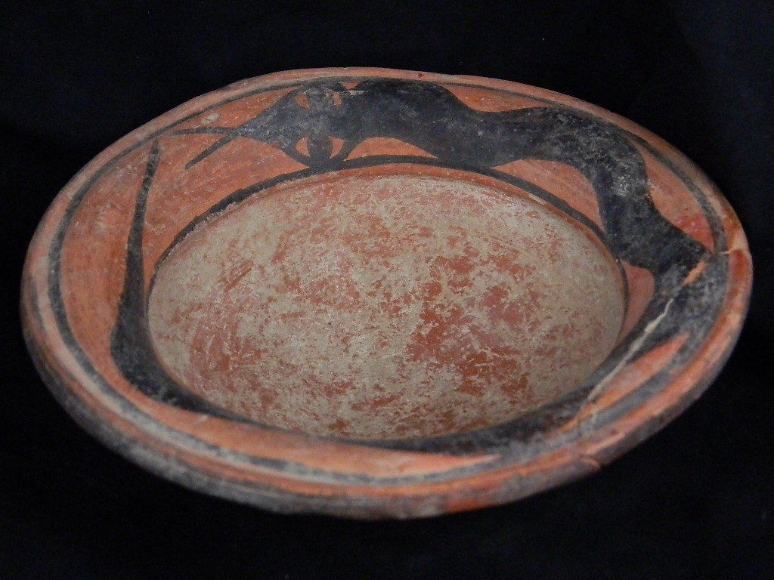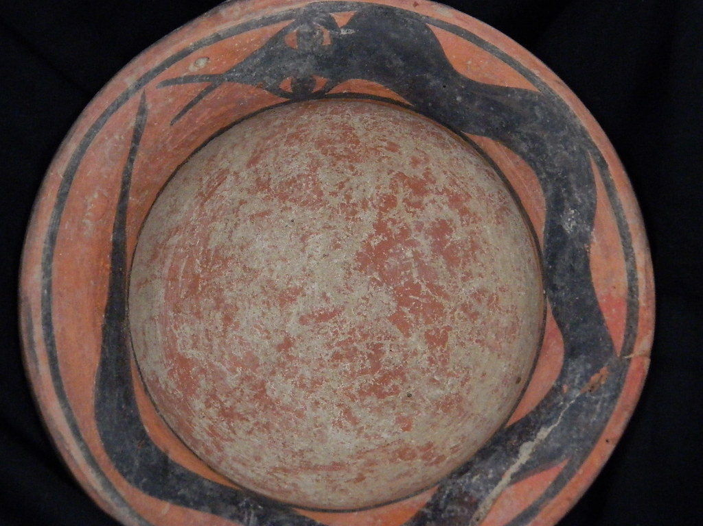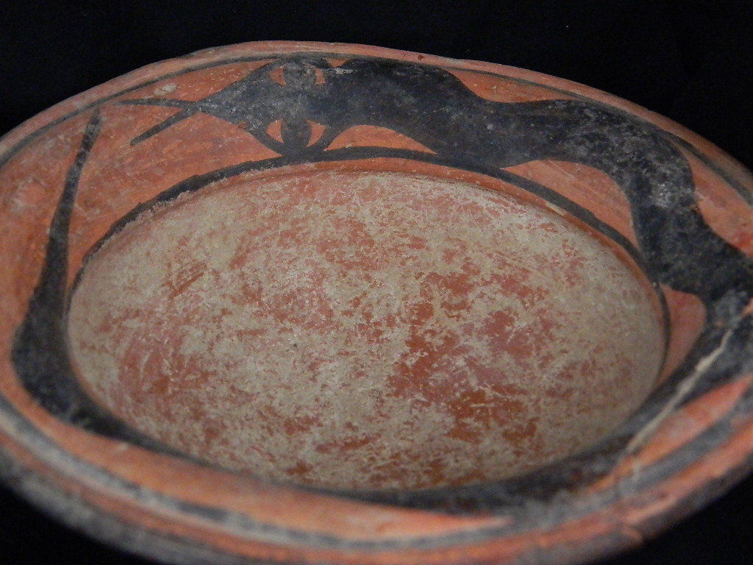

Ancient teracotta painted pot with fishes indus valley circa 2500-3000 BC.  
Combine shipment for mulitiple purchases.  
Shipping/handling $25 worldwide.  
3.5 cm height  
12.5 cm diameter  
Ex: European collection. 